**DIGITAL IMAGE PROCESSING COURSE - 2021.FALL   
PRACTICE LABS**

**LAB 07. REVIEW EXERCISE**

**NUMBER BOUNDING BOXES DETECTION**

Given an image of numbers in black color on a white background. The input image may be affected by noise such as disconnected parts of each number, cluttered background …

Your goal is to make a program using Python finding and drawing the bounding boxes of each number appeared in the given image. A bounding box of a number is a rectangle enclosing the number entirely.

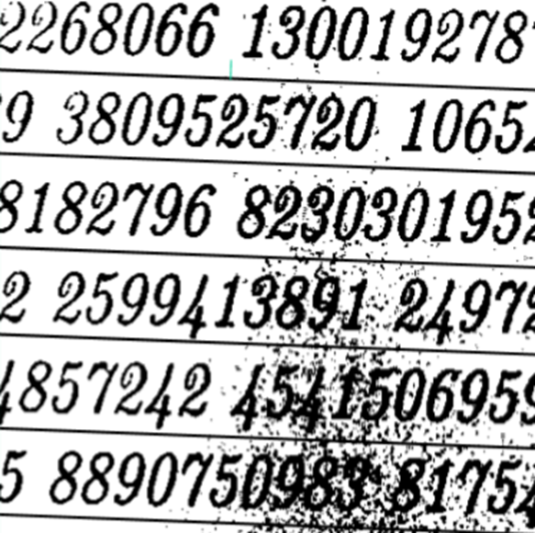

**Input**: a color image (JPEG / PNG)

**Output**:

(1) the original image with number bounding boxes shown in red color (output.jpg)

(2) a text file in which each line including each bounding box information (the top-left coordinates, width and height of each detected bounding box separated by a space character) (output.txt)

**Algorithm**: Any of algorithms or any of OpenCV functions

**Grading:** Points = Number of detected bounding boxes / Number of bounding boxes

**Submission**: Python code + output files via Google Classroom